**RMD SINHGAD SCHOOL OF ENGINEERING AND TECHNICAL EDUCATION**

WARJE, PUNE

*PBL PROJECT REPORT*

VEHICLE SPEED LIMIT MANAGEMENT SYSTEM

**Department of Information Technology**

Members :

Adesh Pawar S-046

Tanmay Borse S-006

Sakshi Bhongale S-003

Rushikesh Sarode S-049

Priti Ugale S-059

Bhakti Vichave S-060

MAY 2021

**Abstract :**

This report represent database management of vehicle speed limit over ruled vehicles information and owners data. Speed detecting apps or techniques use by traffic control department capture the photo of vehicle and textual data can be stored on SQL database.

**Table of content**

|  |  |  |  |
| --- | --- | --- | --- |
| Sr. |  | | Page No. |
|  | Abstract | | ii |
| 1 | Problem statement | | 4 |
| 2 | Introduction | | 5 |
| 3 | Literature library | | **7** |
|  | ***3.1*** | Introduction to DBMS | 7 |
| ***3.2*** | Application of DBMS | 8 |
| ***3.3*** | User interface | 8 |
|  | ***3.4*** | What is MySQL ? | 9 |
| 4 | Use case | | 10 |
|  | ***4.1*** | UML use case diagram | 11 |
| 5 | ER Diagram | | 12 |
| 6 | Data flow diagram | | 13 |
| 7 | Schema diagram | | 14 |
| 8 | Class diagram | | 15 |
| 9 | Sequence diagram | | 16 |
| 10 | Activity diagram | | 17 |
| 11 | Conclusion | | 18 |
| 12 | Future aspect | | 19 |
| 13 | Reference | | 20 |

**Problem Statement :**

Designing and implementing a vehicle speed limit database management system, containing data tables. Such as Detection for storing info getting from location where vehicle is passed.

**Introduction:**

A database management system (DBMS) refers to the technology for creating and managing databases. Basically DBMS is a software tool to organize (create, retrieve, update and manage) data in a database.

***The main aim of a DBMS is to supply a way to store up and retrieve database information that is both convenient and efficient***. Hence our primary goal is store the data and monitor it and perform various operation on it. By data, we mean known facts that can be recorded and that have embedded meaning.

Data of particular can be gathered by RTO office database if we have vehicle number plate picture.

The project is aim at computerizing the manual process of fine collection of speed limit overruled vehicles on highways or roads from owner by sending penalty on their homes.

So basically there are some pathway or segments were vehicles have some speed limit to avoid the accident on roads. Area such as near villages, hospital, schooling areas. But some time people overruled the speed limit so their need a traffic police officer in collect penalty from car owner or bike rider. But this process is manually. Here we try to make their job easy and safe. Also there should need easily view notice board or sign for drivers so they carefully attention of speed limit ahead.

To achieve the easy way penalized system, the vehicle speed monitoring database management has following objectives:

* Research on current method of fine collection.
* Make penalty collection work easier and safer.
* Effective system for traffic control.
* A step for less accident or safe driving.
* Time saving system for traffic officers.

**Literature Survey :**

**Introduction to Database Management System –**

DBMS stands for Database Management System. We can break it like this DBMS=Database +Management System. Database is a collection of data and Management System is a set of programs to store and retrieve those data. Based on this we can define DBMS like this: DBMS is a collection of inter-related data and set of programs to store and access those data in an easy and effective manner.

Database system are basically developed for large amount of data. When dealing with huge amount of data, there are two things that require optimization: Storage of data and retrieval of data. According to the principles of database systems, the data is stored in such a way that it acquires a lot less space as the redundant data (duplicate data) has been removed before storage.

Along with storing the data in an optimized and systematic manner, it is also important that we retrieve the data quickly when needed. Database system ensures that data is retrieved as quickly as possible.

**Application of DBMS :**

The development of computer graphics has been driven both by the needs of the user community and by the advances in hardware and software. The applications of database are many and varied;

1. Hierarchical and network system.
2. Flexibility with relational database.
3. Object oriented application.
4. Interchanging the data on the web for e-commerce.

**User Interfaces :**

Our interactions with computers has become dominated by a visual paradigm that includes windows, icons, menus, pointing device, such as a mouse. Although we are familiar with the syntax of MySQL, advances in MySQL have made possible other forms of advantages.

**What is MySQL? :**

MySQL is multithreaded, multi user SQL database management System (DBMS). The basic program run as server providing multiuser access to a number of databases. The project’s source code is available under terms of the GNU General Public License, as well as under a variety of property arguments. MySQL is a database. The data in a MySQL is stored in a Database objects called tables. A table is a collection of related data entries and it consists of columns and rows. The databases are useful when storing information categorically.

MySQL is a central components of the LAMP open source web application software stack (and other “AMP” stacks). LAMP is an acronym for Linux, Apache, MySQL, Perl/PHP/ Python. Application that use the MySQL database includeTYP03, MODx, Joomla, WordPress, PHPBB, MyBB and Drupal. MySQL is also used in many high profile, large scale web sites, including Google (Though not for the searches).

**Use case :**

The use case analysis will be presented both specified in writing and graphically.

|  |  |
| --- | --- |
| Actor | Use case |
| Police Officer | detect vehicle speed |
| capture image |
| obtain location |
| capture detection time |
| Control Admin | view saved data |
| search saved data by condition |
| owner data |
| monitor and process data |

The Traffic officer and Control admin is shown as actors in the system. There is an include relationship between the Monitor and process data use case and the Detect vehicle speed, Obtain location information, Capture detection time, and the Take vehicle picture use cases because logically the later use cases need to be completed before the Monitor and process data use case can be executed.

However, the include relationship is not direct, it is being implemented through the Capture data use case. The Capture data use case is a generalisation relationship for the Detect vehicle speed, Obtain location information, Capture detection time, and Take vehicle picture use cases, it is included for convenience in the diagram but is not included in the table of use cases.

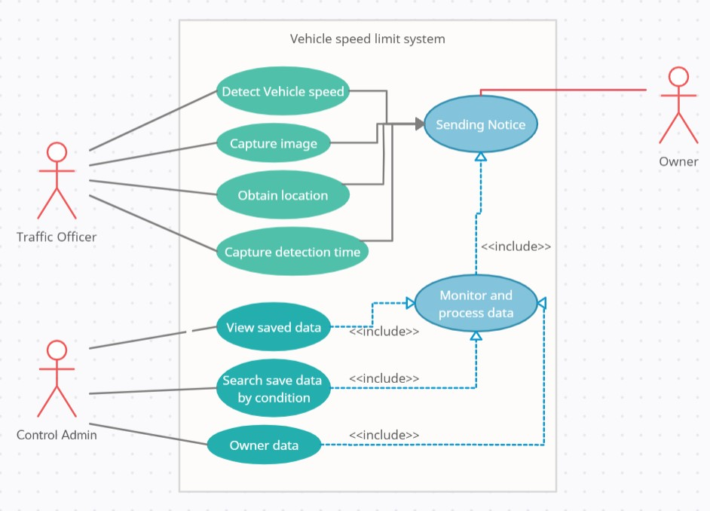

*The system use case diagram*

**ER Diagram :**

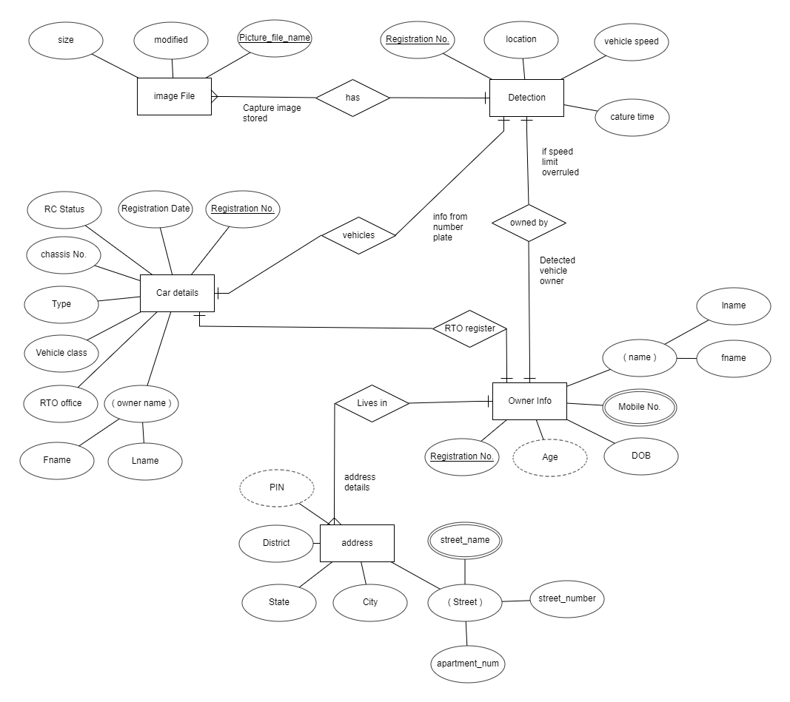

**Data flow diagram :**

**Schema Diagram :**

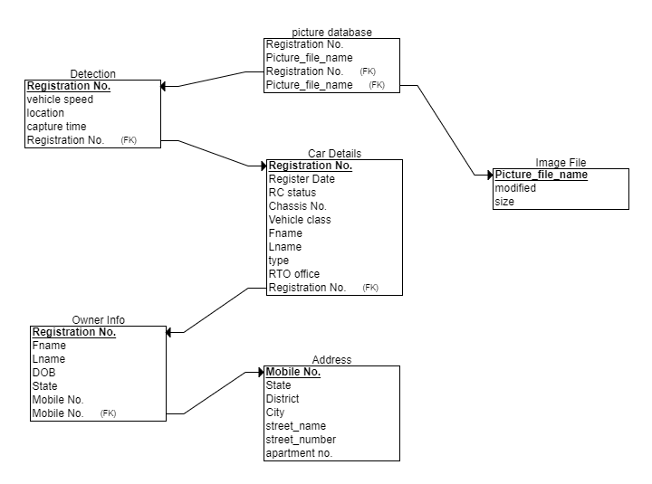

**Class Diagram :**

**Sequence diagram :**

**Activity diagram :**

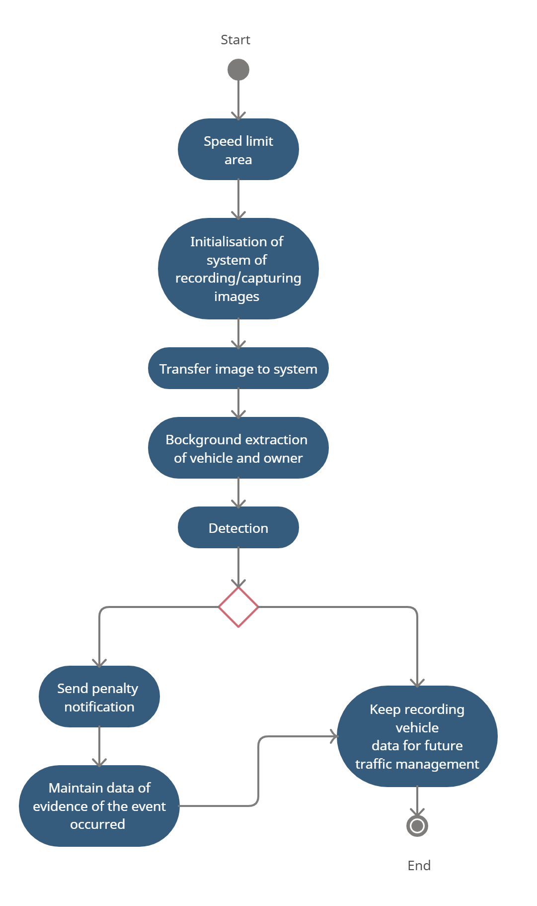

**Conclusion :**

In this project we have created one application which is easy to access and user friendly. The application keeps a backup of the driver’s data management data which includes their details. This system convert manual work to computer organized.

**Future enhancement :**

Till this point we can’t say this system is fully computerized. We need to upgrade some techniques so we handle this system from control rooms in near future.

Here we sending penalty notice to owner house by help of address database. But on time of license approval if it is compulsory for user to register their contact number which linked with bank account so we directly send SMS on their mobile for fined transaction with details regarding their speed limit overruled. Also can link it with Fastag system database in India.

We can also work on making a radar technique that scan and automatic capture vehicle image and send it to web server, controlling database related to speed limit overruled cases of traffic department.

Some of the instances of why and when we would need the details of a vehicle owner are in case of an accident or hit and run case.

In case of purchasing a secondhand vehicle, or an RTO inspection.

**References :**

* <https://app.creately.com/diagram/fHhd6xGmeYe/edit>
* <https://erdplus.com/standalone>
* <https://vahaninfos.com/vehicle-details-by-number-plate#:~:text=You%20can%20check%20following%20things,of%20vahan%2Fvehicle%20in%20India>.
* <https://en.wikipedia.org/wiki/Radar_speed_gun#:~:text=A%20radar%20speed%20gun%20(also,the%20speed%20of%20moving%20objects>.
* <https://www.nolo.com/legal-encyclopedia/free-books/beat-ticket-book/chapter6-1.html#:~:text=the%20pacer's%20observations.-,VASCAR,Speed%20Computer%20and%20Recorder%22>).